**02 NIGHTS MUNNAR EXTENSION**

**DAY 03 KOCHI - MUNNAR**

Breakfast at hotel.

Later drive to Munnar covering a distance of 140kms in 3½ hrs. approximately.

**Munnar** is a magnificent hill station in the Western Ghats at about 5000 feet above sea level and is the major center of Kerala's tea industry. It is surrounded by about 30 tea estates, amongst the highest in the world and a forest that is still rich in wildlife that continues to survive the increasing commercial use of the hills. The luxuriant forest is hung with pepper vines. The hills around Munnar are covered with the rare Neelakurunji plant giving it a wonderful look, especially when the flowers bloom to cover the entire mountain range. It is said that this exotic plant flowers every 12 years.

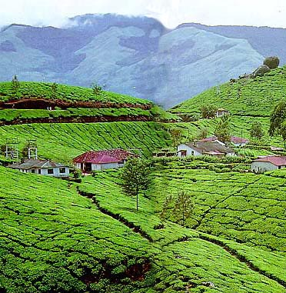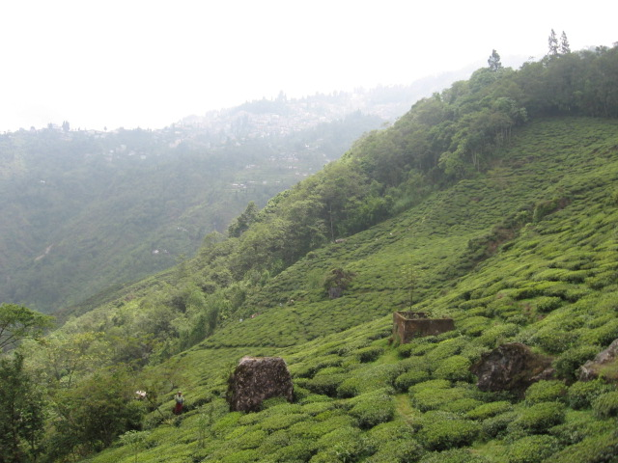

Arrive at Munnar by this afternoon and check in to your hotel for 2 nights.

**Meals included: Breakfast**

**Overnight: Hotel**

**DAY 04 IN MUNNAR**

Full day tour of Munnar visit the plantations, museum etc.

**Meals included: Breakfast**

**Overnight: Hotel**

**DAY 05 MUNNAR _ PERRIYAR**

Morning leave for Periyar & continue the Spice land of Kerala programme thereafter.